# Create a data storytelling dashboard guide

## Project scenario

You're part of the digital marketing analyst team at Friska. Your team has been tasked with designing a visual dashboard that effectively communicates key marketing insights and metrics for Friska deodorant company's digital marketing campaigns. You have been given the specific task to focus on gathering key marketing insights and metrics about Friska’ customers. You will create part of the dashboard that will be used as a final product to present to stakeholders. You will use the same [customer database](https://docs.google.com/spreadsheets/d/1_uJ8j_kqacAETakl8kZ22_peFEbobOstK9zDAu1RuTM/copy#gid=1014526170) and segmentation from Course 1. The marketing objective is still *Increase the online sales volume by 30.0% in 3 months via the Instagram shop in California*.

## Step-by-step instructions

Follow the steps below to create three separate visuals that will be added to your professional portfolio at the end of Course 4.

## Visual 1

### Step 1: Filter data based by country.

In your [customer database](https://docs.google.com/spreadsheets/d/1_uJ8j_kqacAETakl8kZ22_peFEbobOstK9zDAu1RuTM/copy#gid=1014526170) datasheet, you first need to filter the data based by country. Because the marketing goal is focused on California, it’s important to filter by country.

1. Select the entire sheet.
2. Select **Create a filter**icon.

The filter icon highlighted on the toolbar.

1. Select **Sort Z to A** option. This filters the data, and all United States customers are rearranged and now listed at the top of the Google Sheet.

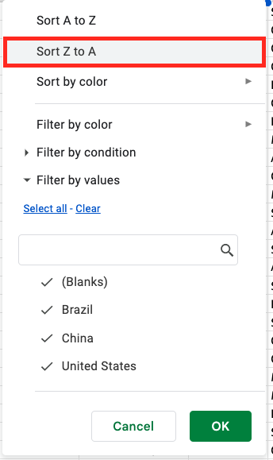

### Step 2: Create a pivot table

Identify the top cities in deodorant sales based off of column G using a [pivot table](https://www.coursera.org/learn/customer-understanding-and-digital-marketing-channels/supplement/o1RMO/spreadsheet-skills).

1. Select anywhere in the Google Sheet.
2. Select **Insert** from the menu.

Google Sheets menu and Insert is highlighted.

1. Select **Pivot table** from the drop-down options.

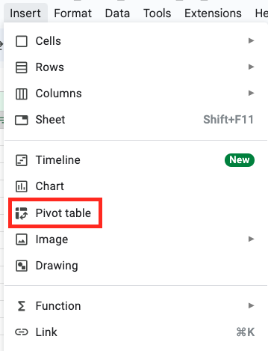

1. Your objective is to focus on the top cities in the United States. The last customer who lives in the United States is row 186. This will be the ending range value for the pivot table. Update the **Data range** to end with G186.

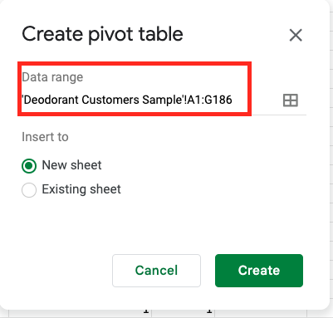

1. Select **Create**. This creates a new tab.
2. Under Pivot table editor, select **Add** that’s next to Rows.
3. Select **City**.

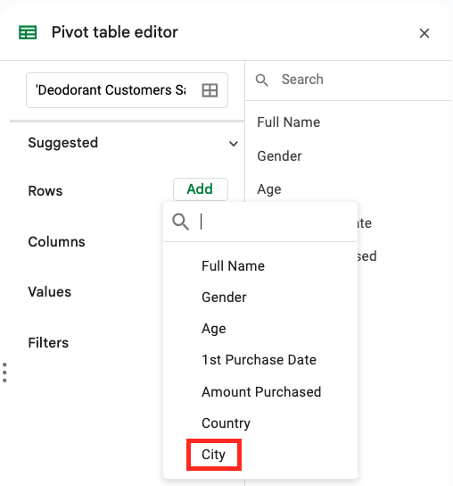

1. Select **Add** next to Values, and then select **Amount Purchased**. Your pivot table will now show city names and values.

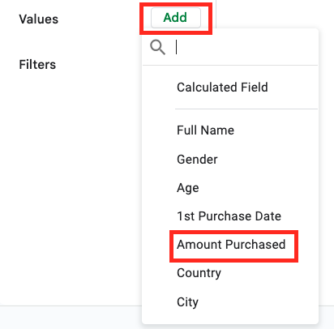

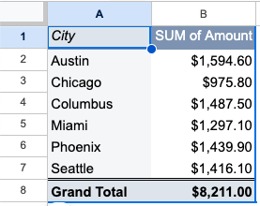

**Note**: A pivot table must include two or more variables to effectively analyze data by cross-referencing and comparing different data points.

### Step 3: Create a visual to display the data

1. Select **Insert**, then select **Chart**.

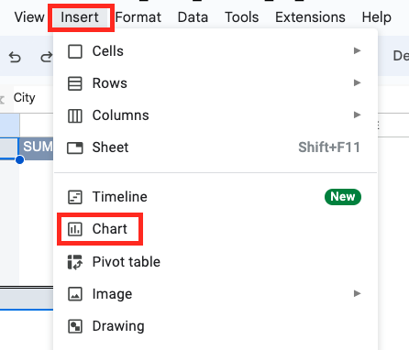

1. In the Chart editor and under Chart type, scroll to the Map options and select **Geo chart with markers**. Your heatmap will appear on the Pivot Table tab.

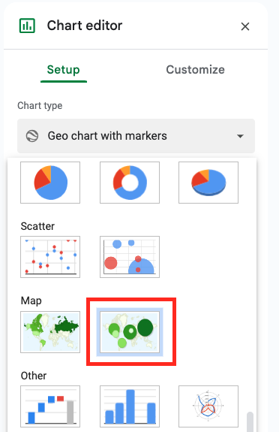

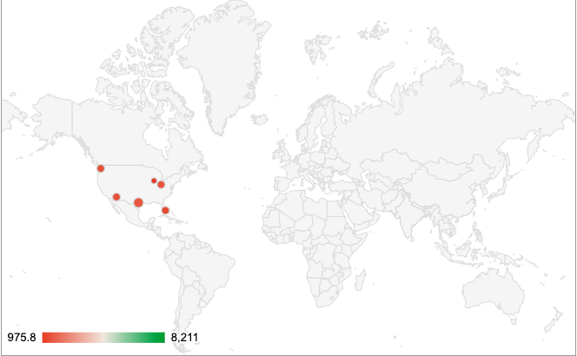

## Visual 2

### Step 1: Compare female versus male sales.

Using the same customer database, create a visual to compare female versus male sales.

### Step 2: Create a new pivot table

* Create a new pivot table based on the data in column A and column B for U.S. customers.
* Use column B to populate *Gender* as your row title in your pivot table.
* Use column A to populate *Value* in your pivot table.
* Under *Gender*, unselect *Show totals.*

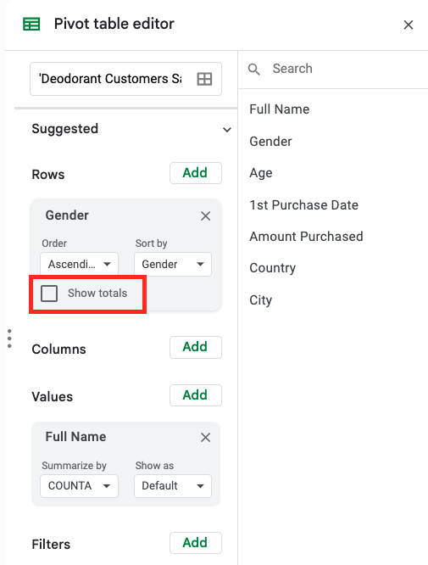

### Step 3: Create a visual to display the data

* Insert a chart to display your data.
* Choose the type of visual that best represents the data.
* Remove the title of the pivot table. You will add a title to your dashboard.

## Visual 3

### Step 1: Analyze amount of first purchase by dates

Using the same customer database, create a visual to analyze the amount of a customer’s first purchase by dates.

### Step 2: Create a new pivot table

* Create a new pivot table based on the data in columns D and E for U.S. customers.
* Use column D to populate *1st Purchase Date* as your row title in your pivot table.
* Use column E to populate *Value* in your pivot table.
* Under *1st Purchase Date*, unselect *Show totals.*

### Step 3: Create a visual to display the data

* Insert a chart to display your data.
* Choose the type of visual that best represents the data.
* Remove the title of the pivot table. You will add a title to your dashboard.

## Add visuals to a dashboard

Now it’s time to add your three visuals you’ve created to a dashboard and make it your own! Make sure the dashboard interface and experience is clear, visible, and accessible for users to consult.

### Step 1: Open the dashboard slides template.

Open the [create a data storytelling dashboard slides](https://docs.google.com/presentation/d/1Jhh0bPWE_TPRb2J0W46nOo1g08JPNpksSF3NPYLI0aI/copy) template. Name and save the slides template to a location where you will be able to easily find it again.

### Step 2: Add the date to the title slide

Add the date, audience, and company name to the title slide. The date and title are important to communicate to stakeholders how current the dashboard is and what it’s about.

### Step 3: Add visual 1 to the dashboard

Add the first visual (geo chart with markers) you created in this activity to the dashboard on slide 2. It’s titled *Audience demographics: Purchases by city*. It’s important to include a title that describes what the visual is displaying.

### Step 4: Add visual 2 to the dashboard

Add the second visual you created in this activity to the dashboard on slide 3. It’s titled *Audience demographics: Purchases by gender*.

### Step 5: Add visual 3 to the dashboard

Add the third visual you created in this activity to the dashboard on slide 4.

### Step 6: Add a title for visual 3

Think about what information is being displayed in visual 3, and add a descriptive title for slide 4.

### Make it your own - optional!

Select from the different slide theme options to make your data storytelling dashboard your own! In real life, don’t forget to design the presentation following your company’s brand identity guidelines (e.g., fonts, colors, iconography).

When you’re ready, go back to [the assignment](https://www.coursera.org/learn/campaign-performance-reporting-visualization-improvement/assignment-submission/XbpGj/create-a-data-storytelling-dashboard/attempt) to complete the reflective questions.